Programming Assignment-2

Trilok Raj Thailam

Tt363

**Github Link:**

https://github.com/tt363/CS643862.git

**Connection to Elastic Map Reduce(EMR):**

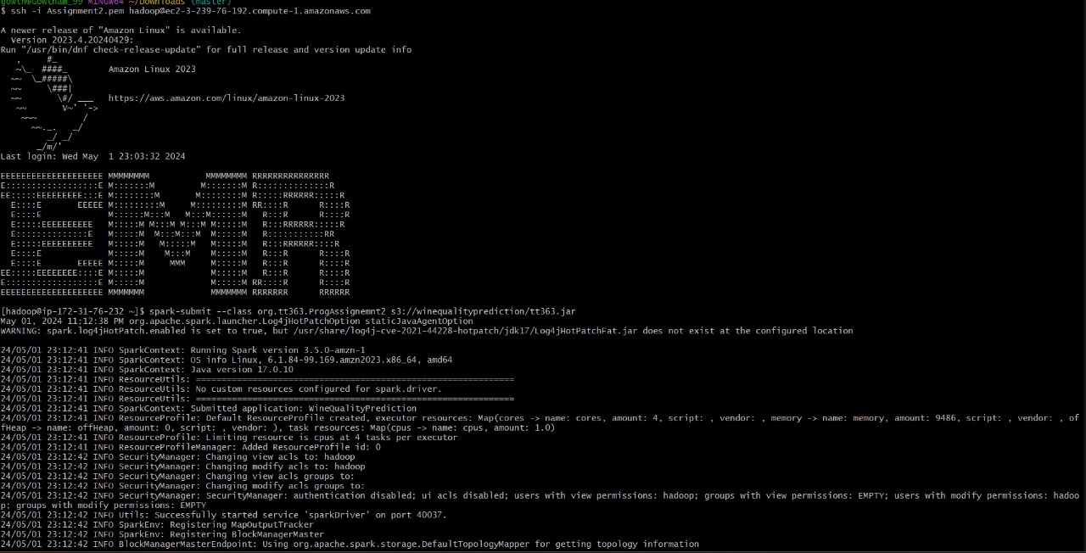

**Models Accuracy and F1 score using spark:**

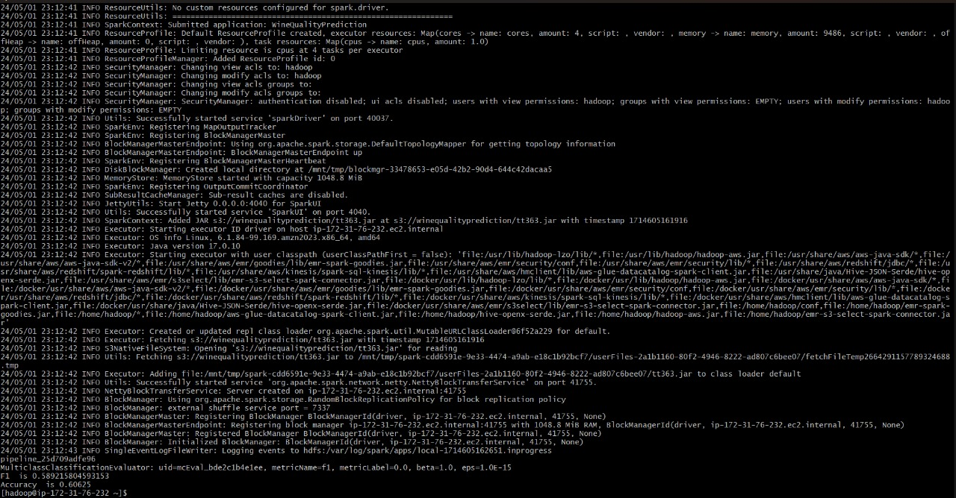

**S3 Bucket:**

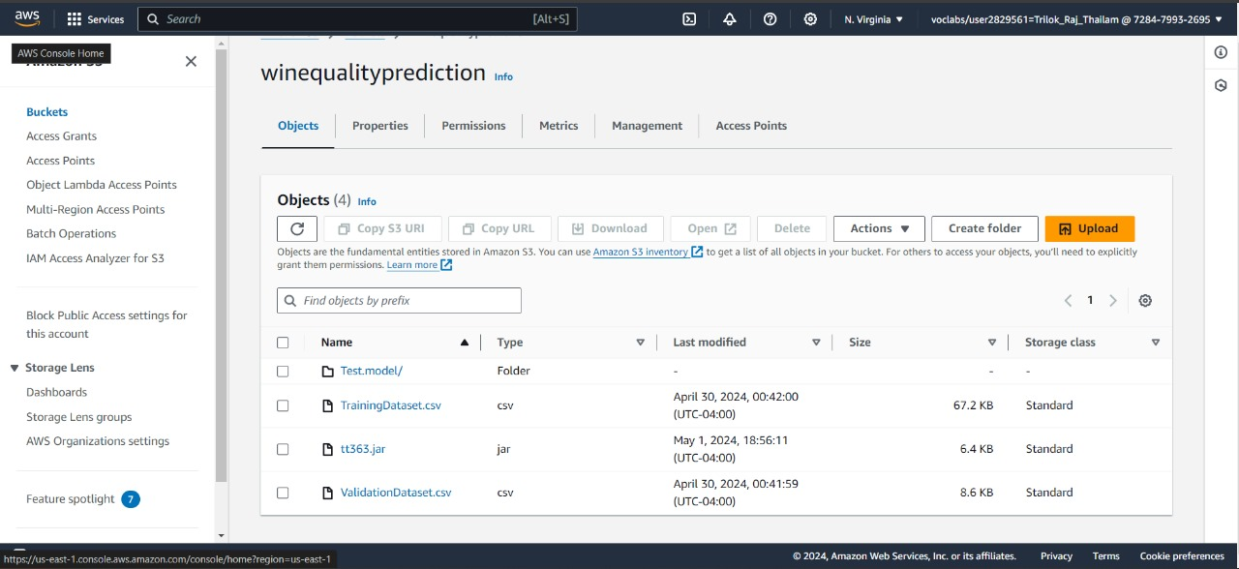

**EMR running with four instances:**

